Lab Manual
Lab # 2
MICROSOFT WORD
OPEN WORD DOCUMENT:
You can open a Word document by right clicking on the desktop and then select “Microsoft Office Word Document” as shown below
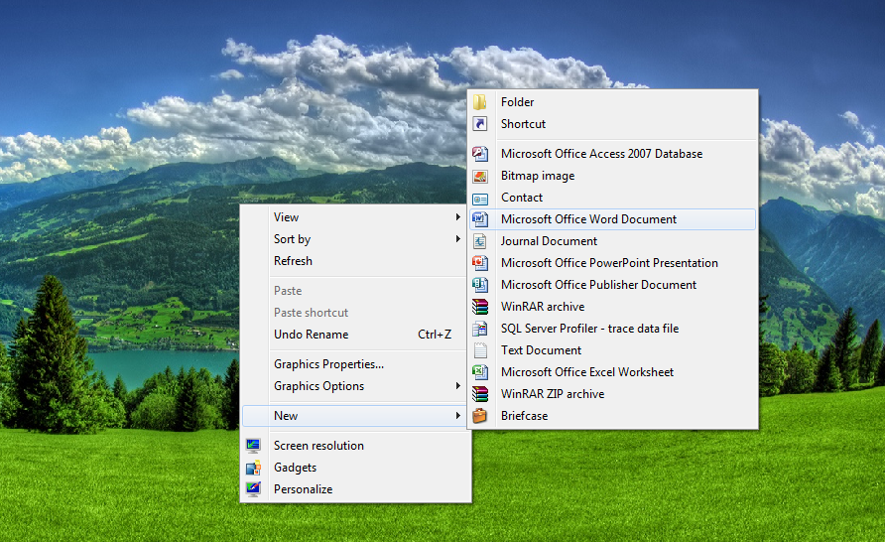
You can also open a word document from start menu, just click on the start menu and then select “Microsoft Office Word Document”.
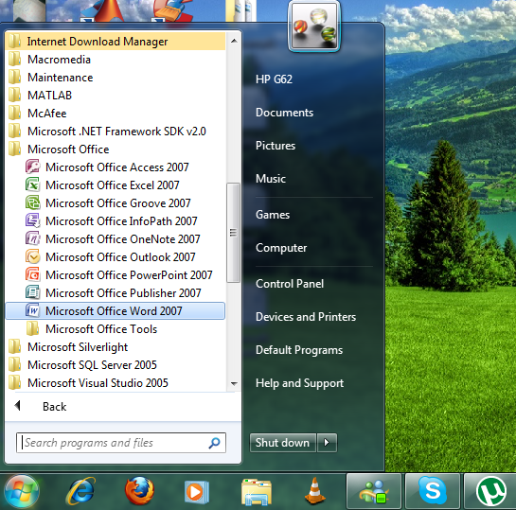

FONT STYLE:
different font styles can be selected as shown below.
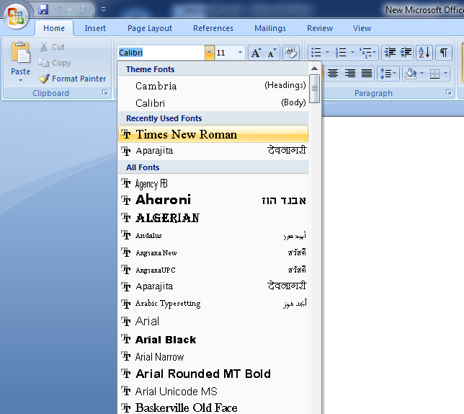
FONT SIZE:
Font size can be changed from the following option.
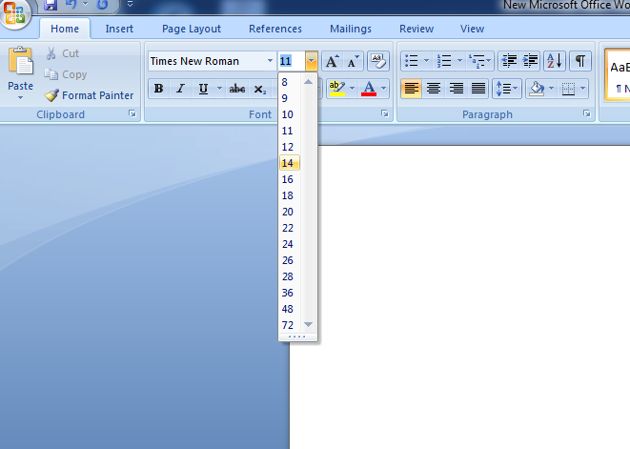
BOLD:
To make any part of your text bold in Microsoft Word, you have to highlight the text. With your text highlighted, click the "B" icon. Your text will turn bold.
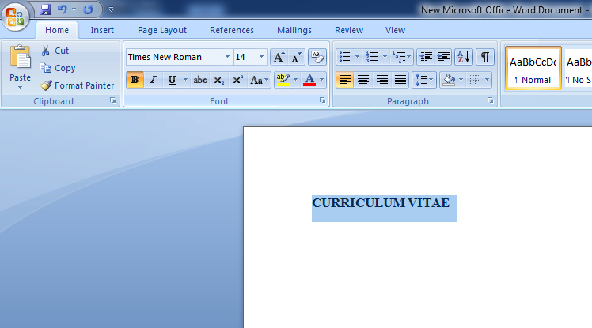
ITALIC:
To make any part of your text bold in Microsoft Word, you have to highlight the text. With your text highlighted, click the "I" icon. Your text will turn ITALIC.
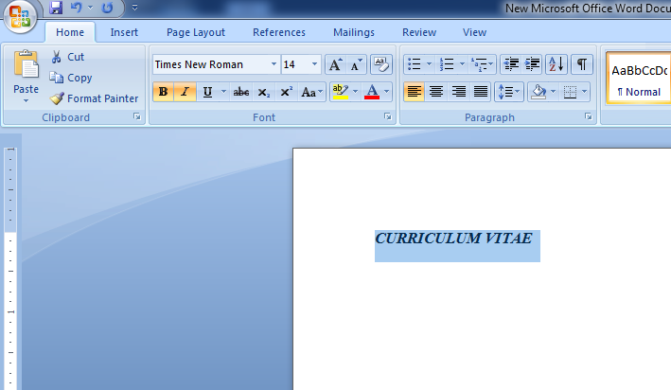

UNDERLINE:
To underline some text, click the letter "U" of the shown icons. The keyboard shortcut is Ctrl plus the letter "U".
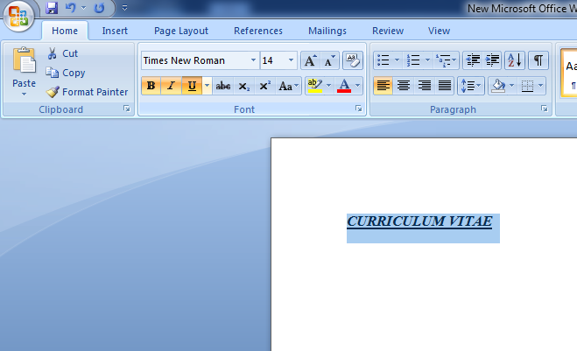
FONT COLOR:
Font color can be changed by selecting the following option.
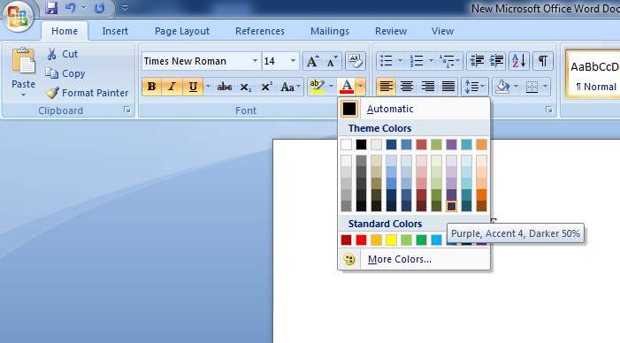

ALIGNMENT:
You can align the text to the left, right or at the center of the page. For that first of all highlight the text, once you have highlighted the text you can align it to the left or right side of the page. To do that we use the alignment icons on the tool bar.
LEFT
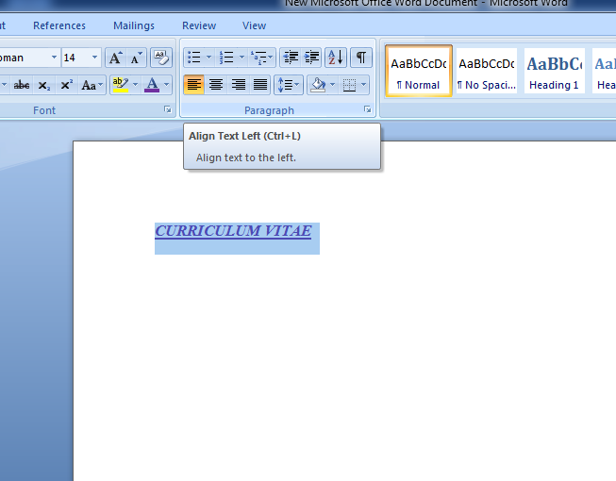
CENTER

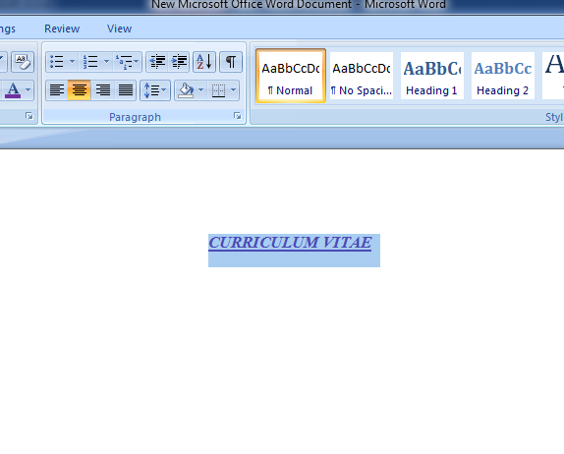

RIGHT
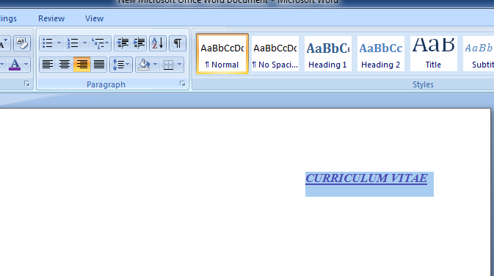
JUSTIFY
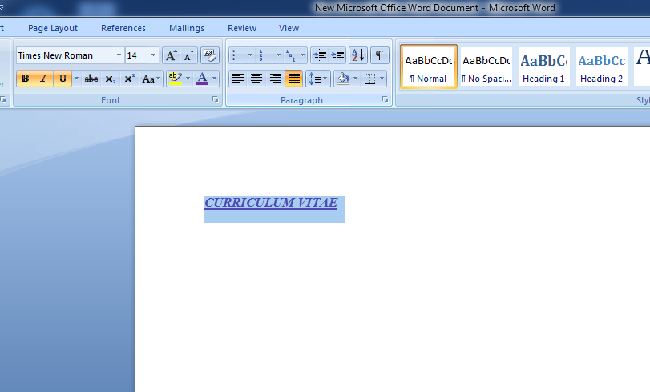

BULLETS:
Bulleted lists can be created in the document. To create the bulleted list highlight the lines and then select your desired bullet style.
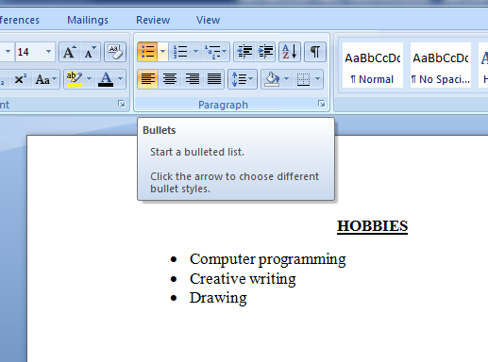
NUMBERING:
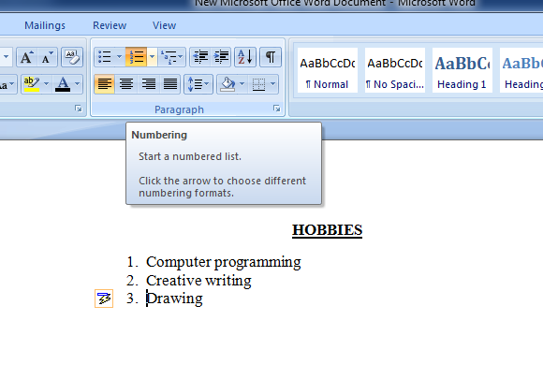
TABLE:
There are three other ways to add a table using the menu above. The first one is with the white squares. Move your mouse over the squares and you'll see them highlighted. Highlight the same ones as in the image below (6 columns and 6 rows). Once you've highlighted the correct squares left click to add the table to your blank page. It should look like this:
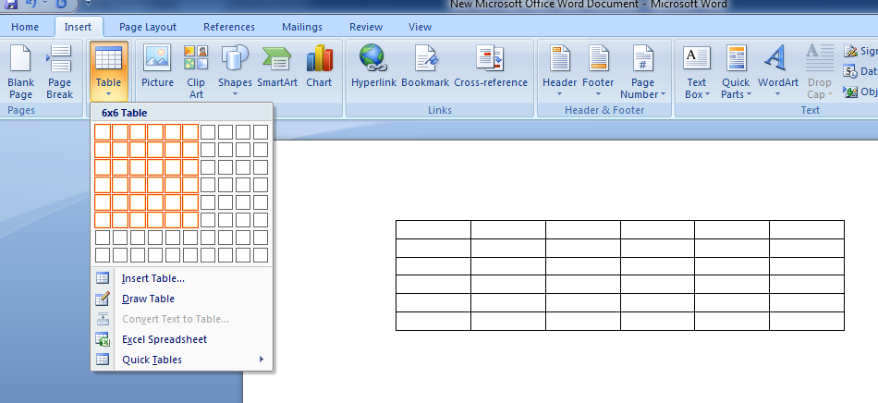
HEADER AND FOOTER:
Headers and footers are pieces of text or graphics that appear at the top and bottom of a page. After you set up a header and footer, they will appear on all of your pages. You can add a page number to a header or footer, and Microsoft Word will automatically insert the right page number for you.
To set up a header and footer for your document, click on the Insert tab at the top of Word. Now locate the Header & Footer panel:
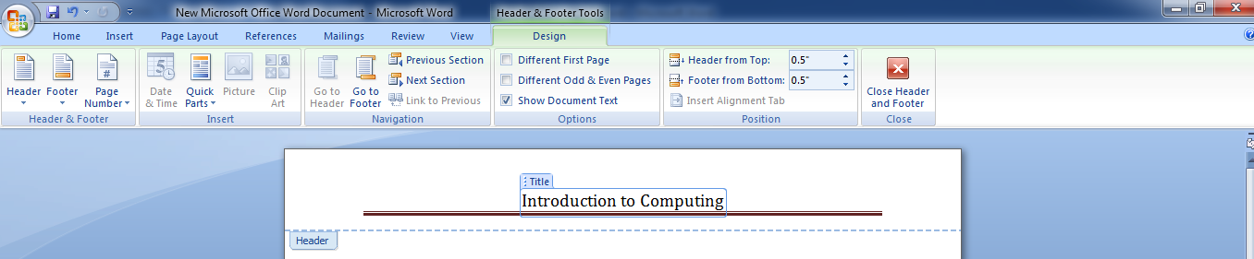
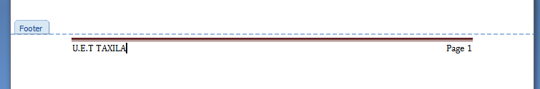

BORDER AND SHADING:
Borders and shading options can be selected from the page layout tab.
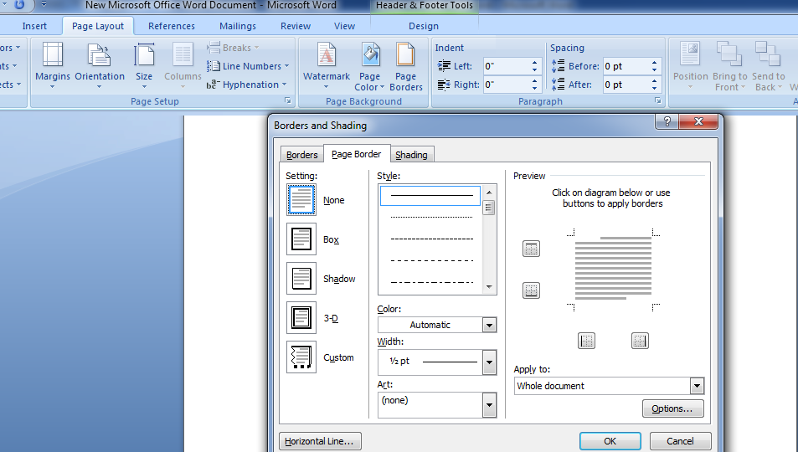

SPELLING AND GRAMMAR IN WORD:
One thing you probably will have noticed is the spelling mistakes in the document. You should have typed the letter exactly as it was, and left any spelling errors in. More than likely, the spelling mistakes are underlined in red in your document. Anything with a wiggly green line under it is a grammatical error, (or what Microsoft Word insists is a grammatical error).
